I'll help you analyze your rule-based chatbot project and create a comprehensive explanation for your college seminar. Let me start by exploring your project structure.

Now let me read the key files to understand the project functionality:

Perfect! Now I have a complete understanding of your project. Let me create a comprehensive seminar explanation for your rule-based chatbot project.

# 🤖 **Rule-Based Chatbot Project - College Seminar Explanation**

## 1️⃣ **Project Overview (Simple Language)**

**What is this project?**
- Yeh ek **Rule-Based Chatbot** hai jo user se baat karta hai
- User koi message bhejta hai, bot uska **pre-defined rules** ke according reply deta hai
- Example: agar user "hi" bolta hai to bot "Hello! How can I help you?" bolta hai

**Why this project is needed?**
- College websites, banks, hospitals mein **24/7 support** chahiye
- Human agents **sare time available nahi ho sakte**
- Chatbot **common questions** ka instant answer de sakta hai
- **Cost-effective** solution hai businesses ke liye

**Problem it solves:**
- User ko wait nahi karna padta for simple queries
- **Repetitive questions** handle karne mein help karta hai
- **Customer service** improve karta hai

---

## 2️⃣ **Folder & File Analysis**

### 📁 **Root Folder Structure**
```
rule_based_chatbot/
├── app.py # 🧠 Main backend file
├── requirements.txt # 📦 Python dependencies
├── .env # 🔐 Database credentials
├── static/ # 🎨 Frontend assets
├── templates/ # 📄 HTML pages
└── venv/ # 🐍 Python virtual environment
```
### 📁 **static/ Folder - Frontend Assets**
```
static/
├── css/
│ └── style.css # 🎨 Chatbot ka design & styling
└── js/
└── chat.js # ⚡ Frontend JavaScript logic
```

**Important Files:**
- **style.css**: Chatbox ka modern design, colors, buttons
- **chat.js**: User message handle karta hai, backend se baat karta hai

### 📁 **templates/ Folder - HTML Pages**
```
templates/
├── chat.html # 💬 User chat interface
└── admin.html # ⚙️ Admin panel for rules management
```

**Important Files:**
- **chat.html**: User ka chat interface - input box, chat display
- **admin.html**: Admin panel - rules add/edit/delete karne ke liye

---

## 3️⃣ **Architecture Explanation**

### 🎯 **Frontend (Client Side)**
**Technology:** HTML + CSS + JavaScript
- **HTML**: Structure banata hai (chatbox, input field)
- **CSS**: Beautiful design deta hai (blue theme, rounded corners)
- **JavaScript**: User input handle karta hai, backend se data bhejta hai

### 🎯 **Backend (Server Side)**
**Technology:** Python Flask Framework
- **Flask**: Web framework hai jo HTTP requests handle karta hai
- **MySQL Connector**: Database se connect karne ke liye
- **REST API**: Frontend aur backend ke beech communication

### 🎯 **Database**
**Technology:** MySQL Database
- **rules table**: Chatbot ke patterns aur responses store karta hai
- **chat_logs table**: User conversations record karta hai

---

## 4️⃣ **Connection Flow (Most Important)**

### 🔄 **Complete Request-Response Cycle**

**Step 1:** User types message in chatbox
**Step 2:** JavaScript ([chat.js](cci:7://file:///c:/Users/ACER/OneDrive/Desktop/Project/rule_based_chatbot/static/js/chat.js:0:0-0:0)) captures the message
**Step 3:** Frontend sends POST request to `/chat` endpoint
**Step 4:** Backend ([app.py](cci:7://file:///c:/Users/ACER/OneDrive/Desktop/Project/rule_based_chatbot/app.py:0:0-0:0)) receives the request
**Step 5:** Backend connects to MySQL database
**Step 6:** Backend searches for matching pattern in rules table
**Step 7:** Database returns matching response
**Step 8:** Backend sends JSON response back to frontend
**Step 9:** JavaScript displays bot response in chatbox
**Step 10:** Backend logs the conversation in chat_logs table

---

## 5️⃣ **Real-Time Example - User Says "hi"**

### 📝 **Complete Flow Breakdown:**

1. **User Action:** Types "hi" and clicks Send
2. **JavaScript:** [sendMessage()](cci:1://file:///c:/Users/ACER/OneDrive/Desktop/Project/rule_based_chatbot/static/js/chat.js:16:0-49:1) function called
3. **HTTP Request:** `POST /chat` with `{"message": "hi"}`
4. **Backend Processing:**
```python
user_message = "hi"
user_lower = "hi"
# Database query: SELECT * FROM rules WHERE pattern = 'hi'
```
5. **Database Response:** Returns `{"pattern": "hi", "response": "Hello! How can I help?"}`
6. **Backend Response:** `{"response": "Hello! How can I help?"}`
7. **Frontend Display:** Shows bot message in blue bubble
8. **Logging:** Saves conversation to database

## 6️⃣ **Workflow Diagram**
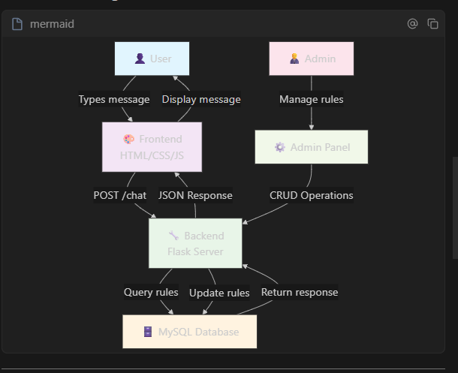
```mermaid
graph TD
A[👤 User] -->|Types message| B[🎨 Frontend<br/>HTML/CSS/JS]
B -->|POST /chat| C[🔧 Backend<br/>Flask Server]
C -->|Query rules| D[🗄️ MySQL Database]
D -->|Return response| C
C -->|JSON Response| B
B -->|Display message| A
E[👨‍💼 Admin] -->|Manage rules| F[⚙️ Admin Panel]
F -->|CRUD Operations| C
C -->|Update rules| D

style A fill:#e1f5fe
style B fill:#f3e5f5
style C fill:#e8f5e8
style D fill:#fff3e0
style E fill:#fce4ec
style F fill:#f1f8e9
```

---

## 7️⃣ **Key Features & Technologies**

### 🚀 **Main Features:**
1. **Real-time Chat** - Instant responses
2. **Rule Management** - Admin can add/edit/delete rules
3. **Pattern Matching** - Exact match + contains match
4. **Fallback Response** - Default message for unknown queries
5. **Chat Logging** - All conversations saved

### 🛠️ **Tech Stack:**
- **Frontend:** HTML5, CSS3, Vanilla JavaScript
- **Backend:** Python 3.x, Flask Framework
- **Database:** MySQL
- **API:** RESTful API (JSON format)
- **Styling:** Modern CSS with Flexbox

---

## 8️⃣ **Code Highlights**

### 📄 **Backend Route Example:**
```python
@app.route('/chat', methods=['POST'])
def chat():
user_message = request.get_json().get('message', '').strip()
# Pattern matching logic
# Database operations
return jsonify({"response": response})
```

### 📄 **Frontend JavaScript Example:**
```javascript
fetch('/chat', {
method: 'POST',
headers: { 'Content-Type': 'application/json' },
body: JSON.stringify({ message: message })
})
.then(response => response.json())
.then(data => addMessage(data.response, false));
```

---

## 🎯 **Summary for Students**

**Simple Explanation:**
- **Frontend** = User ka face (chatbox jo dikhta hai)
- **Backend** = Dimmag (logic jo messages process karta hai)
- **Database** = Yaad (rules aur conversations store karta hai)

**Learning Points:**
1. How web applications work
2. Client-server architecture
3. Database integration
4. REST API design
5. Frontend-backend communication

**Future Enhancements:**
- AI/ML integration for smart responses
- Multiple language support
- Voice chat capability
- File sharing features

